IS 420 Assignment 4

Due 4/20

Suppose you have created tables in assignment 1. **Please write PL/SQL program for the following problems. Please include both code and screenshots.**

Problem 1: [40 points]

Write a PL/SQL **function** that given email of an editor, compute the number of papers assigned to the editor with pending reviews. A paper with pending review means that the paper has some reviews with NULL receive_date.

This function also checks a special case when the editor email does not match any existing editors, and returns -1 in this case.

Please also write an anonymous PL/SQL program to call this function with a few different editor emails to test both the regular and special case.

**Screenshots:**

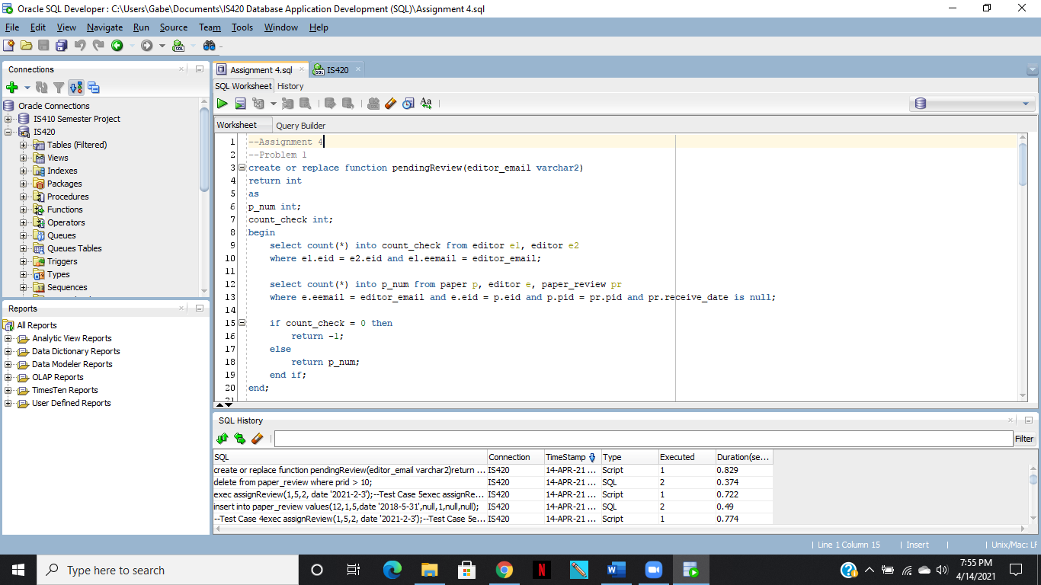

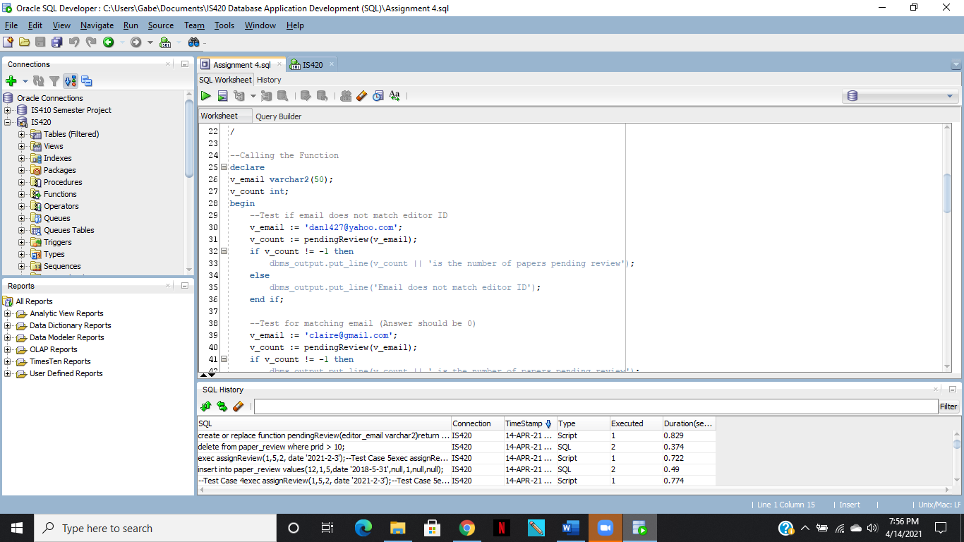

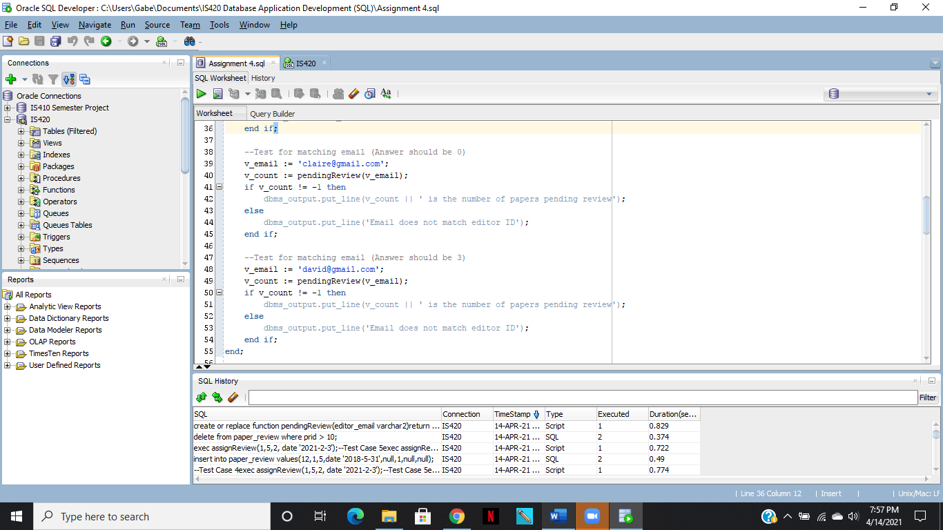

**Results:**

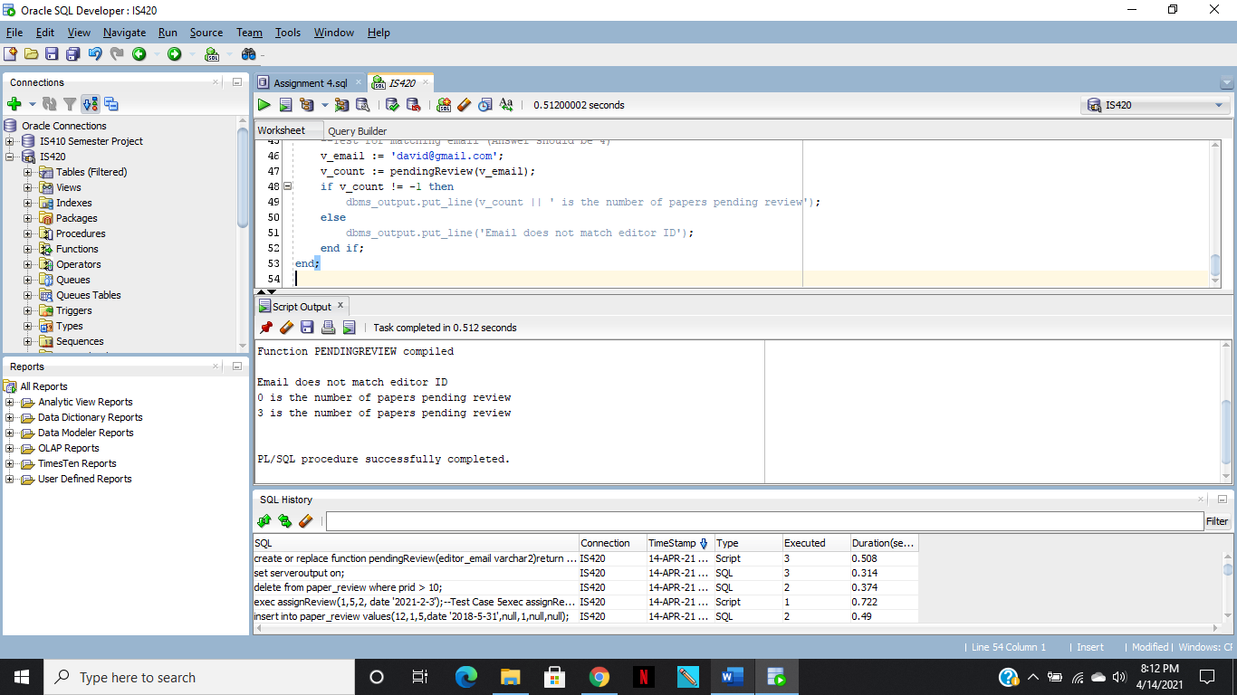

**Code:**

create or replace function pendingReview(editor_email varchar2)

return int

as

p_num int;

count_check int;

begin

select count(*) into count_check from editor e1, editor e2

where e1.eid = e2.eid and e1.eemail = editor_email;

select count(*) into p_num from paper p, editor e, paper_review pr

where e.eemail = editor_email and e.eid = p.eid and p.pid = pr.pid and pr.receive_date is null;

if count_check = 0 then

return -1;

else

return p_num;

end if;

end;

/

--Calling the Function

declare

v_email varchar2(50);

v_count int;

begin

--Test if email does not match editor ID

v_email := 'dan1427@yahoo.com';

v_count := pendingReview(v_email);

if v_count != -1 then

dbms_output.put_line(v_count || 'is the number of papers pending review');

else

dbms_output.put_line('Email does not match editor ID');

end if;

--Test for matching email (Answer should be 0)

v_email := 'claire@gmail.com';

v_count := pendingReview(v_email);

if v_count != -1 then

dbms_output.put_line(v_count || ' is the number of papers pending review');

else

dbms_output.put_line('Email does not match editor ID');

end if;

--Test for matching email (Answer should be 3)

v_email := 'david@gmail.com';

v_count := pendingReview(v_email);

if v_count != -1 then

dbms_output.put_line(v_count || ' is the number of papers pending review');

else

dbms_output.put_line('Email does not match editor ID');

end if;

end;

Problem 2: [60 points] Write a PL/SQL procedure that assigns a reviewer to a paper in a certain round of review. The input includes a paper ID, reviewer ID, round, and due date.

The procedure does ALL of the following:

1) First check whether there is a paper with the given paper ID, if not, print an error message 'Wrong paper ID' and stop;

2) Next check whether there is a reviewer with the input reviewer ID. If not, print an error message 'wrong reviewer ID' and stop.

3) Next check whether there is already a row in paper_review with given paper ID, reviewer ID, and round. If so, print a message 'Already assigned' and stop.

4) Now check whether there is a conflict of interest, i.e., whether any author of the paper and the input reviewer has the same affiliation. If a conflict exists, print a message 'X and Y have conflict of interest' where X and Y are the names of author and reviewer with the same affiliation and stop. Please note that a paper may have multiple authors with the same affiliation with the reviewer.

5) If none of the above happens, insert a row to paper_review with given paper ID, reviewer ID, round, due date, and give null values to receive_date, decision and comment. Please use a sequence to generate new prid and print out the new prid. Please include the drop sequence and create sequence command before the procedure creation code such that your procedure can be created correctly.

Please also include exec procedure code to test all 5 cases (5 test case needed). You will lose points if not all test cases are included.

**Screenshots:**

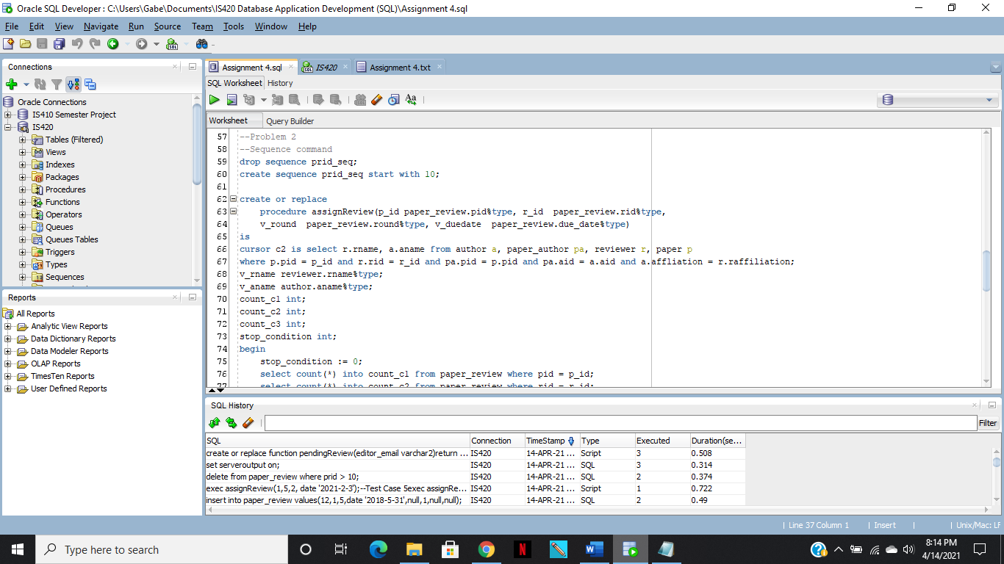

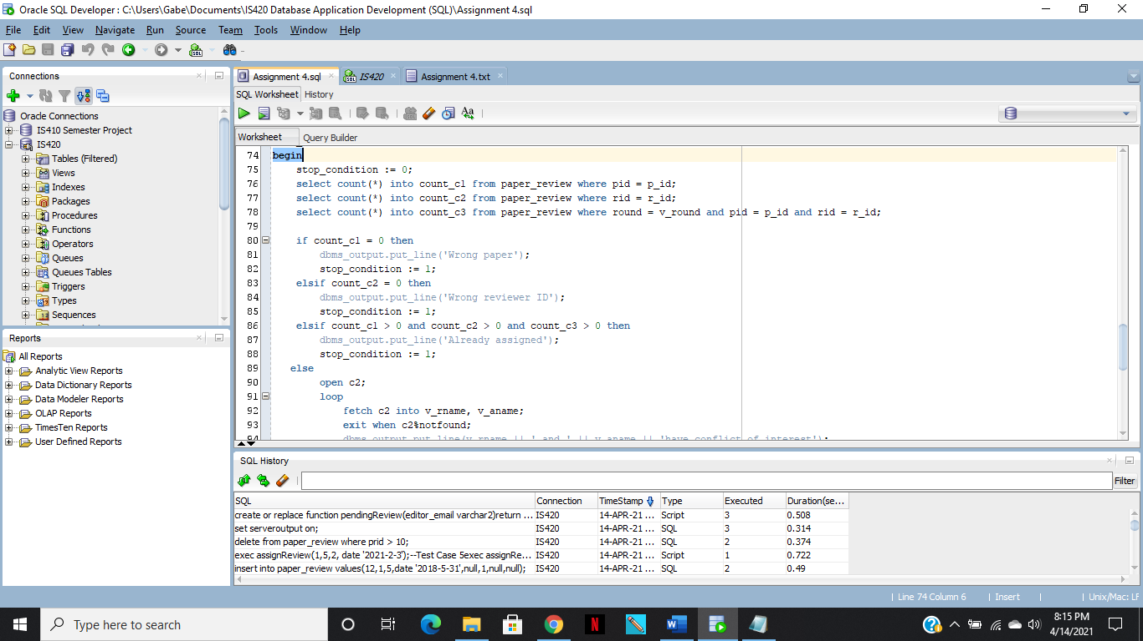

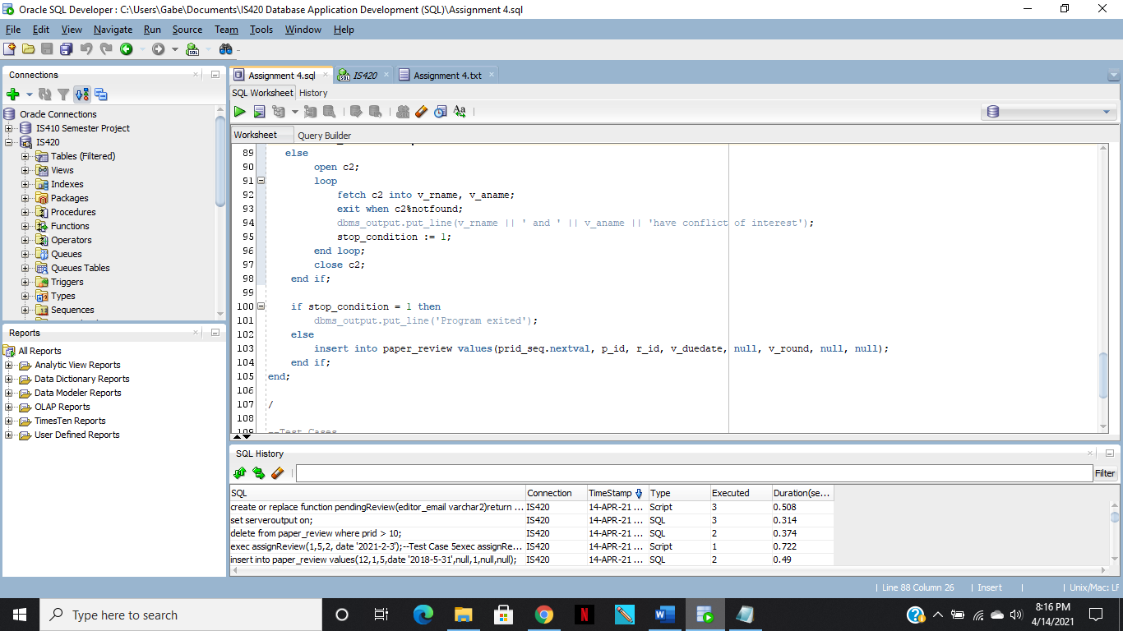

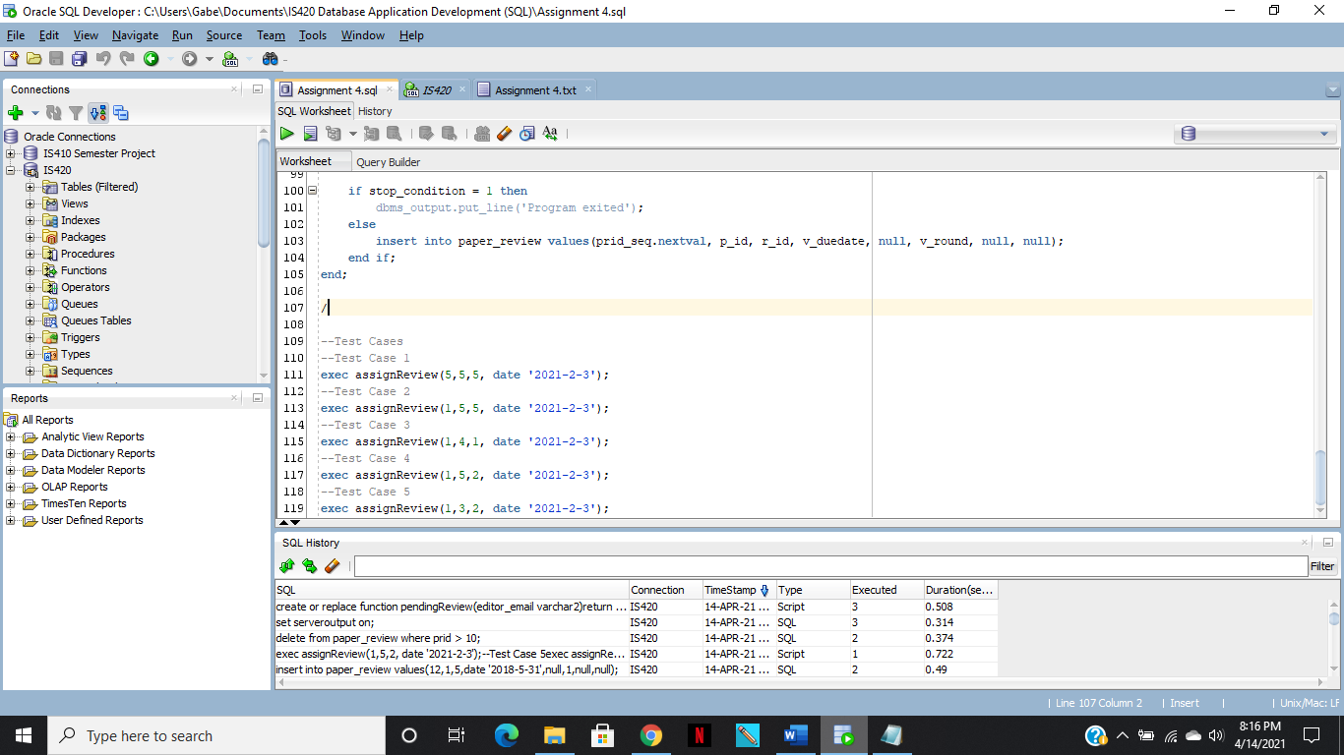

**Code:**

--Sequence command

drop sequence prid_seq;

create sequence prid_seq start with 10;

create or replace

procedure assignReview(p_id paper_review.pid%type, r_id paper_review.rid%type,

v_round paper_review.round%type, v_duedate paper_review.due_date%type)

is

cursor c2 is select r.rname, a.aname from author a, paper_author pa, reviewer r, paper p

where p.pid = p_id and r.rid = r_id and pa.pid = p.pid and pa.aid = a.aid and a.affliation = r.raffiliation;

v_rname reviewer.rname%type;

v_aname author.aname%type;

count_c1 int;

count_c2 int;

count_c3 int;

stop_condition int;

begin

stop_condition := 0;

select count(*) into count_c1 from paper_review where pid = p_id;

select count(*) into count_c2 from paper_review where rid = r_id;

select count(*) into count_c3 from paper_review where round = v_round and pid = p_id and rid = r_id;

if count_c1 = 0 then

dbms_output.put_line('Wrong paper');

stop_condition := 1;

elsif count_c2 = 0 then

dbms_output.put_line('Wrong reviewer ID');

stop_condition := 1;

elsif count_c1 > 0 and count_c2 > 0 and count_c3 > 0 then

dbms_output.put_line('Already assigned');

stop_condition := 1;

else

open c2;

loop

fetch c2 into v_rname, v_aname;

exit when c2%notfound;

dbms_output.put_line(v_rname || ' and ' || v_aname || 'have conflict of interest');

stop_condition := 1;

end loop;

close c2;

end if;

if stop_condition = 1 then

dbms_output.put_line('Program exited');

else

insert into paper_review values(prid_seq.nextval, p_id, r_id, v_duedate, null, v_round, null, null);

end if;

end;

/

--Test Cases

--Test Case 1

exec assignReview(5,5,5, date '2021-2-3');

--Test Case 2

exec assignReview(1,5,5, date '2021-2-3');

--Test Case 3

exec assignReview(1,4,1, date '2021-2-3');

--Test Case 4

exec assignReview(1,5,2, date '2021-2-3');

--Test Case 5

exec assignReview(1,3,2, date '2021-2-3');